excel functions manual

Naam: Rayane Van de Venne

Klas: 6IB

Schooljaar: 2022-2023

introduction

Welcome to this comprehensive Excel functions manual designed for school students. As you know, Excel is a powerful tool for data analysis and management, widely used in academia, research, and business. However, mastering Excel can be challenging, particularly for beginners. With its vast array of functions and tools, it can be overwhelming and confusing to navigate. That's where this manual comes in.

In this guide, we provide a detailed overview of the essential Excel functions that you need to know to be an effective user. Our focus is on functions that are commonly used in academic settings and it can help you with tasks such as data analysis, graphing, and report writing.

We start with an introduction to the Excel interface and tools, providing a basic understanding of the software's layout and features. We then dive into the essential functions, grouping them into categories such as mathematical, logical, text, and lookup and reference functions.

Each function is explained in detail, including its purpose, syntax, and examples of how to use it effectively. We also provide practical tips and tricks to make your Excel experience more efficient and productive.

Whether you are a beginner or an intermediate Excel user, this manual will equip you with the skills and knowledge necessary to navigate Excel with ease. By the end of this guide, you will be able to analyze data, create charts and graphs, and organize information effectively.

We hope you find this manual helpful and informative. Let's get started on your journey to Excel mastery!

TABLE OF CONTENTS

1 Basic Functions 4

1.1 SUM Function 4

1.2 AVERAGE Function 5

1.3 COUNT Function 6

1.4 MIN Function 7

1.5 MAX Function 8

2 Text Functions 9

2.1 CONCATENATE Function 9

2.2 LEN Function 10

2.3 LEFT Function 11

2.4 RIGHT Function 12

2.5 MID Function 13

3 Logical Functions 14

3.1 IF Function 14

3.2 AND Function 15

3.3 OR Function 16

4 Date an Time Functions 17

4.1 TODAY Function 17

**Error! Bookmark not defined.**

4.2 NOW Function 18

**Error! Bookmark not defined.**

5 Math Functions 19

5.1 ROUND Function 19

5.2 SUMIF Function 20

**Error! Bookmark not defined.**

5.3 COUNTIF Function 21

Error! Bookmark not defined.

6 Lookup and Reference Functions 22

6.1 VLOOKUP Function 22

6.2 HLOOKUP Function 23

# Basic Functions

## SUM Function

The SUM function in Excel is used to add up values within a range of cells. To use the SUM function, select the cell where you want the total to appear and then type "SUM(" into the formula bar. Next, select the range of cells you want to add up by clicking and dragging over the cells or typing in the cell range (e.g. A1:A10). Once you have selected the range, close the parentheses and press enter. The cell will then display the total of the selected range.

It is important to note that the SUM function only adds up numeric values, so any non-numeric values in the selected range will be ignored. Additionally, you can use the SUM function to add up multiple ranges of cells by separating them with commas within the parentheses (e.g. SUM(A1:A10,B1:B10)).

In summary, the SUM function is a useful tool in Excel for quickly calculating the total of a range of numeric values.

Here is a screenshot to illustrate the process:

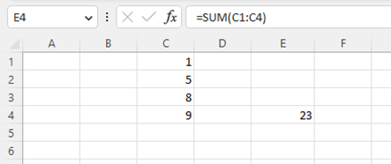

## AVERAGE Function

The AVERAGE function in Excel is used to calculate the average of a set of numbers. It is often used in data analysis to find the central value of a data set. To use the AVERAGE function, follow these steps:

1 Select the cell where you want to display the average.

2 Type the formula =AVERAGE( in the cell.

3 Select the range of cells that contains the numbers you want to average.

4 Close the formula with a closing parenthesis ) and press Enter.

For example, if you wanted to find the average of the numbers in cells A1 through A5, you would enter =AVERAGE(A1:A5) in the cell where you want the result to appear.

It is important to note that the AVERAGE function will only calculate the average of the cells that contain numerical values. If a cell in the range contains text or is empty, it will be ignored in the calculation.

Here is a screenshot to illustrate the process:

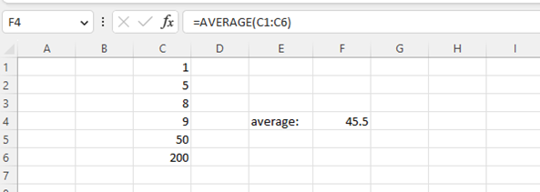

COUNT Function

The COUNT function in Excel is used to count the number of cells in a range that contain numeric values. This function is particularly useful when you need to quickly determine the number of items in a data set.

1 To use the COUNT function in Excel:

2 Select the cell where you want the result to appear.

3 Type "=COUNT(" and then select the range of cells that you want to count. The range can include numbers, names, arrays, or references to cells containing numbers.

4 Close the parentheses and press Enter.

Excel will count the number of cells in the selected range that contain numeric values and return the result in the selected cell.

Note that the COUNT function does not count cells that contain text, logical values, or errors. If you need to count cells that contain a specific type of data, such as text, you can use the COUNTIF function instead.

Here is an example of how to use the COUNT function:

Let's say you have a list of test scores in cells A1 through A10, and you want to count the number of scores that are above 80. Here's how you could use the COUNT function to do this:

1 Select the cell where you want the result to appear.

2 Type "=COUNTIF(A1:A10,">80")" and press Enter.

Excel will count the number of cells in the range A1:A10 that are greater than 80 and return the result in the selected cell.

Here is a screenshot to illustrate the process:

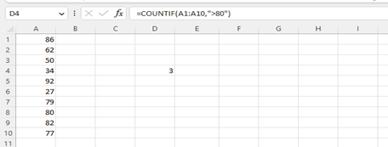

MIN Function

The MIN function in Excel is used to find the minimum value in a range of cells. It is a useful tool for quickly identifying the smallest value in a set of data.

To use the MIN function, you need to select the range of cells you want to search for the minimum value. Then, you can type "=MIN(" into the formula bar and select the range of cells. The function will automatically find the smallest value in the selected range and return it in the cell where the formula was entered.

For example, if you have a range of cells containing the values 5, 8, 2, and 10, you can use the MIN function to quickly find the smallest value, which is 2. The formula would look like this: "=MIN(A1:A4)".

It is important to note that the MIN function only works with numerical values. If there are any text values or empty cells in the range, the function will return an error.

Here is a screenshot to illustrate the process:

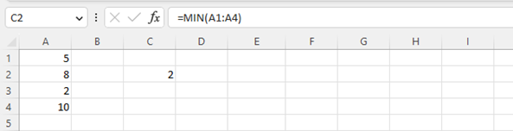

MAX Function

The MAX function in Excel is used to find the largest value within a given range of cells. This function can be particularly useful when working with large sets of data and wanting to quickly identify the highest value.

To use the MAX function, first select the cell where you want the result to appear. Then, type "=MAX(" and select the range of cells that you want to find the maximum value for. Close the bracket and press enter. The maximum value within the range will then be displayed in the selected cell.

It is important to note that the MAX function only returns the highest value within a range of cells, so if there are multiple values that are tied for the highest, it will only return one of them. Additionally, if there are any non-numeric values within the range, the function will return an error.

Here is a screenshot to illustrate the process:

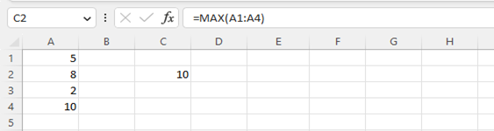

# Text Functions

## CONCATENATE Function

The CONCATENATE function in Microsoft Excel is a formula that allows users to combine text from different cells into a single cell. This function is commonly used to create a full name from separate first and last name columns, or to combine multiple pieces of information into a single cell.

To use the CONCATENATE function, the user must first select the cell where they want the concatenated text to appear. Next, they must enter the formula "=CONCATENATE(" into the cell, followed by the cell references of the cells they wish to concatenate, separated by commas. For example, to combine the text in cells A1 and B1, the formula would be "=CONCATENATE(A1,B1)".

It is important to note that the text being concatenated must be enclosed in quotation marks within the formula, otherwise Excel will return an error. Additionally, if the user wants to include a space or other separator between the concatenated text, they can simply include it within the quotation marks.

The CONCATENATE function can also be combined with other formulas or text strings to create more complex concatenated text. For example, to include a title before a person's name, the formula might be "=CONCATENATE("Mr. ",A1,B1)".

Overall, the CONCATENATE function in Excel is a useful tool for combining text from multiple cells into a single cell. By following the proper syntax and using quotation marks as necessary, users can easily create customized text strings for their data.

Here is a screenshot to illustrate the process:

Note: You have to add the quotation marks with a space in between in order to get the space between the first name and the last name.

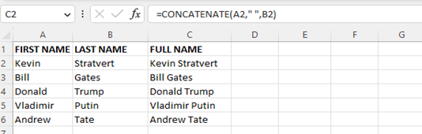

## LEN Function

The LEN function in Microsoft Excel is a formula that returns the number of characters in a given cell. This function is commonly used to determine the length of text strings, including words, phrases, and sentences.

To use the LEN function, the user must first select the cell where they want to display the result. Next, they must enter the formula "=LEN(" into the cell, followed by the cell reference of the cell containing the text they want to count the characters for. For example, to count the number of characters in cell A1, the formula would be "=LEN(A1)".

It is important to note that the LEN function counts all characters in a cell, including spaces and special characters. If the user only wants to count specific characters or words, they may need to use additional functions or formulas to achieve this.

The result of the LEN function will always be a numeric value, indicating the number of characters in the specified cell. This value can then be used in other calculations or functions as needed.

Overall, the LEN function in Excel is a useful tool for determining the length of text strings. By using this function, users can easily obtain the number of characters in a given cell and use this information for a variety of purposes, such as formatting, data analysis, or data validation.

Here is a screenshot to illustrate the process:

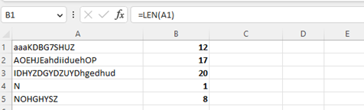

## LEFT Function

The LEFT function in Microsoft Excel is a formula that returns a specified number of characters from the beginning of a given text string. This function is commonly used to extract a specific subset of characters from a longer text string.

To use the LEFT function, the user must first select the cell where they want to display the result. Next, they must enter the formula "=LEFT(" into the cell, followed by the cell reference of the cell containing the text they want to extract characters from, and the number of characters they want to extract. For example, to extract the first three characters from cell A1, the formula would be "=LEFT(A1,3)".

It is important to note that the number of characters to extract must be a numeric value, and cannot exceed the total number of characters in the text string. If the specified number of characters exceeds the length of the text string, the function will return an error.

The result of the LEFT function will be a new text string containing only the specified number of characters from the beginning of the original text string. This new text string can then be used in other formulas or functions as needed.

Overall, the LEFT function in Excel is a useful tool for extracting a specific subset of characters from a longer text string. By using this function, users can easily obtain the desired characters and use them for a variety of purposes, such as formatting, data analysis, or data validation.

Here is a screenshot to illustrate the process:

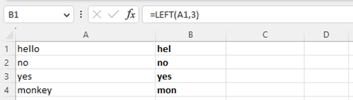

## RIGHT Function

The RIGHT function in Microsoft Excel is a formula that returns a specified number of characters from the end of a given text string. This function is commonly used to extract a specific subset of characters from a longer text string.

To use the RIGHT function, the user must first select the cell where they want to display the result. Next, they must enter the formula "=RIGHT(" into the cell, followed by the cell reference of the cell containing the text they want to extract characters from, and the number of characters they want to extract. For example, to extract the last four characters from cell A1, the formula would be "=RIGHT(A1,4)".

It is important to note that the number of characters to extract must be a numeric value, and cannot exceed the total number of characters in the text string. If the specified number of characters exceeds the length of the text string, the function will return an error.

The result of the RIGHT function will be a new text string containing only the specified number of characters from the end of the original text string. This new text string can then be used in other formulas or functions as needed.

Overall, the RIGHT function in Excel is a useful tool for extracting a specific subset of characters from a longer text string. By using this function, users can easily obtain the desired characters and use them for a variety of purposes, such as formatting, data analysis, or data validation.

Here is a screenshot to illustrate the process:

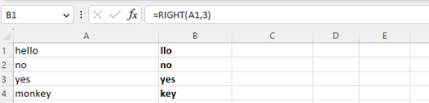

## MID Function

The MID function in Microsoft Excel is a formula that extracts a specified number of characters from a given text string, starting at a specified position. This function is commonly used to extract a substring from a longer text string.

To use the MID function, the user must first select the cell where they want to display the result. Next, they must enter the formula "=MID(" into the cell, followed by the cell reference of the cell containing the text they want to extract characters from, the starting position of the characters to extract, and the number of characters to extract. For example, to extract four characters starting at the fifth character position in cell A1, the formula would be "=MID(A1,5,4)".

It is important to note that the starting position must be a numeric value that is greater than or equal to 1, and the number of characters to extract must be a numeric value that does not exceed the total number of characters in the text string starting from the starting position. If the starting position or number of characters to extract are not valid, the function will return an error.

The result of the MID function will be a new text string containing only the specified number of characters starting from the specified starting position in the original text string. This new text string can then be used in other formulas or functions as needed.

Overall, the MID function in Excel is a useful tool for extracting a specific substring from a longer text string. By using this function, users can easily obtain the desired characters and use them for a variety of purposes, such as formatting, data analysis, or data validation.

Here is a screenshot to illustrate the process:

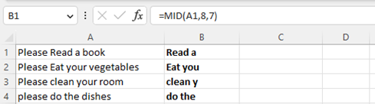

# Logical Functions

## IF Function

The IF function in Microsoft Excel is a formula that allows the user to specify a condition to test, and returns one value if the condition is true and another value if the condition is false. This function is commonly used to analyze data and make decisions based on specific criteria.

To use the IF function, the user must first select the cell where they want to display the result. Next, they must enter the formula "=IF(" into the cell, followed by the condition to test, the value to return if the condition is true, and the value to return if the condition is false.

For example, to test whether the value in cell A1 is greater than 10, and return "Yes" if true and "No" if false, the formula would be "=IF(A1>10,"Yes","No")". It is important to note that the condition to test can be any logical expression that evaluates to either true or false. If the condition is true, the function will return the value specified for true; if the condition is false, the function will return the value specified for false.

The result of the IF function will be a new value that is either the true or false value specified in the formula. This new value can then be used in other formulas or functions as needed.

Overall, the IF function in Excel is a useful tool for analyzing data and making decisions based on specific criteria. By using this function, users can easily test conditions and return values based on those conditions, allowing for more efficient and effective data analysis.

Here is a screenshot to illustrate the process:

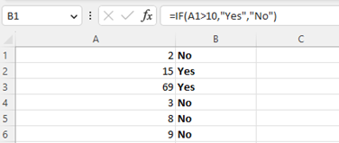

## AND Function

The AND function in Microsoft Excel is a formula that allows the user to test whether multiple conditions are true, and returns true if all conditions are true, or false if any condition is false. This function is commonly used to perform logical tests on data.

To use the AND function, the user must first select the cell where they want to display the result. Next, they must enter the formula "=AND(" into the cell, followed by the conditions to test, separated by commas. For example, to test whether the values in cells A1 and A2 are both greater than 10, the formula would be "=AND(A1>10,A2>10)".

It is important to note that the conditions to test can be any logical expressions that evaluate to either true or false. If all conditions are true, the function will return true; if any condition is false, the function will return false.

The result of the AND function will be a new value that is either true or false, depending on whether all conditions are true. This new value can then be used in other formulas or functions as needed.

Overall, the AND function in Excel is a useful tool for performing logical tests on data. By using this function, users can easily test multiple conditions and return a single value that indicates whether all conditions are true or false, allowing for more efficient and effective data analysis.

Here is a screenshot to illustrate the process:

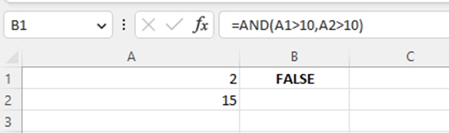

## OR Function

The OR function in Microsoft Excel is a formula that allows the user to test whether at least one of multiple conditions is true, and returns true if any condition is true, or false if all conditions are false. This function is commonly used to perform logical tests on data.

To use the OR function, the user must first select the cell where they want to display the result. Next, they must enter the formula "=OR(" into the cell, followed by the conditions to test, separated by commas. For example, to test whether the value in cell A1 is greater than 10 or the value in cell B1 is greater than 10, the formula would be "=OR(A1>10,B1>10)".

It is important to note that the conditions to test can be any logical expressions that evaluate to either true or false. If at least one condition is true, the function will return true; if all conditions are false, the function will return false.

The result of the OR function will be a new value that is either true or false, depending on whether at least one condition is true. This new value can then be used in other formulas or functions as needed.

Overall, the OR function in Excel is a useful tool for performing logical tests on data. By using this function, users can easily test multiple conditions and return a single value that indicates whether at least one condition is true or false, allowing for more efficient and effective data analysis.

Here is a screenshot to illustrate the process:

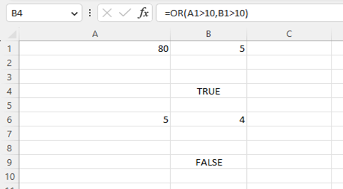

# Date an Time Functions

## TODAY Function

The TODAY function in Microsoft Excel is a formula that allows the user to display the current date in a cell. This function is commonly used to keep track of dates and to calculate the difference between dates.

To use the TODAY function, the user must first select the cell where they want to display the current date. Next, they must enter the formula "=TODAY()" into the cell.

The result of the TODAY function will be the current date, displayed in the cell in the format specified by the user.The date will automatically update each time the worksheet is opened or when the worksheet is recalculated.

It is important to note that the TODAY function does not take any arguments, and therefore there are no parameters to set.

Overall, the TODAY function in Excel is a useful tool for displaying the current date in a cell. By using this function, users can easily keep track of dates and calculate the difference between dates, allowing for more efficient and effective data analysis.

Here is a screenshot to illustrate the process:

## 

## NOW Function

The NOW function in Microsoft Excel is a formula that allows the user to display the current date and time in a cell. This function is commonly used to keep track of dates and times and to calculate the difference between dates and times.

To use the NOW function, the user must first select the cell where they want to display the current date and time. Next, they must enter the formula "=NOW()" into the cell.

The result of the NOW function will be the current date and time, displayed in the cell in the format specified by the user. The date and time will automatically update each time the worksheet is opened or when the worksheet is recalculated.

It is important to note that the NOW function does not take any arguments, and therefore there are no parameters to set.

Overall, the NOW function in Excel is a useful tool for displaying the current date and time in a cell. By using this function, users can easily keep track of dates and times and calculate the difference between dates and times, allowing for more efficient and effective data analysis.

Here is a screenshot to illustrate the process:

## 

# Math Functions

## ROUND Function

The ROUND function in Microsoft Excel is a formula that allows the user to round a number to a specified number of digits. This function is commonly used to simplify the data and make it easier to read.

To use the ROUND function, the user must first select the cell where they want to display the rounded number. Next, they must enter the formula "=ROUND(" into the cell, followed by the number to round, a comma, and the number of decimal places to round to. For example, to round the number in cell A1 to two decimal places, the formula would be "=ROUND(A1,2)".

It is important to note that the ROUND function can round to a specified number of decimal places, or to a specified multiple of 10, 100, 1000, and so on. The user can choose the rounding method that best suits their needs.

The result of the ROUND function will be a new value that is rounded to the specified number of digits. This new value can then be used in other formulas or functions as needed.

Overall, the ROUND function in Excel is a useful tool for simplifying data and making it easier to read. By using this function, users can easily round numbers to a specified number of digits or a specified multiple, allowing for more efficient and effective data analysis.

Here is a screenshot to illustrate the process:

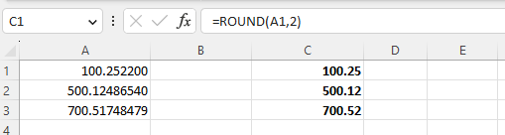

## SUMIF Function

The SUMIF function in Microsoft Excel is a formula that allows the user to add up values in a range based on a specified condition or criteria. This function is commonly used to calculate totals for specific categories or subsets of data.

To use the SUMIF function, the user must first select the cell where they want to display the sum. Next, they must enter the formula "=SUMIF(" into the cell, followed by the range of cells to evaluate, the condition or criteria to apply, and the range of cells to sum up. For example, to sum up the values in cells A1 to A10 that are greater than 5, the formula would be "=SUMIF(A1:A10,">5")".

It is important to note that the SUMIF function can also be used with multiple criteria by adding additional ranges and conditions to the formula. The user can choose the criteria that best suits their needs.

The result of the SUMIF function will be the sum of the values in the specified range that meet the specified condition or criteria. This sum can then be used in other formulas or functions as needed.

Overall, the SUMIF function in Excel is a useful tool for calculating totals for specific categories or subsets of data. By using this function, users can easily add up values based on a specified condition or criteria, allowing for more efficient and effective data analysis.

Here is a screenshot to illustrate the process:

## 

## COUNTIF Function

The COUNTIF function in Microsoft Excel is a formula that allows the user to count the number of cells in a range that meet a specified condition or criteria. This function is commonly used to calculate the number of occurrences of a specific value or to count cells that meet certain criteria.

To use the COUNTIF function, the user must first select the cell where they want to display the count. Next, they must enter the formula "=COUNTIF(" into the cell, followed by the range of cells to evaluate and the condition or criteria to apply. For example, to count the number of cells in the range A1 to A10 that contain the value "apples", the formula would be "=COUNTIF(A1:A10,"apples")".

It is important to note that the COUNTIF function can also be used with multiple criteria by adding additional ranges and conditions to the formula.

The user can choose the criteria that best suits their needs. The result of the COUNTIF function will be the number of cells in the specified range that meet the specified condition or criteria. This count can then be used in other formulas or functions as needed.

Overall, the COUNTIF function in Excel is a useful tool for counting the number of cells that meet specific criteria. By using this function, users can easily count occurrences of a specific value or count cells that meet certain criteria, allowing for more efficient and effective data analysis.

Here is a screenshot to illustrate the process:

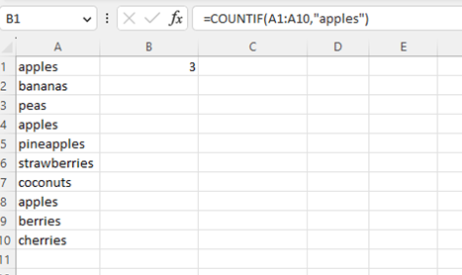

# Lookup and Reference Functions

## VLOOKUP Function

The VLOOKUP function in Microsoft Excel is a formula that allows the user to look up a specific value in a table and retrieve information from that table based on a specified column. This function is commonly used to search for data in a large table or database and retrieve information associated with that data.

To use the VLOOKUP function, the user must first select the cell where they want to display the result. Next, they must enter the formula "=VLOOKUP(" into the cell, followed by the value they want to look up, the range of cells where the lookup value is located, the column number where the desired information is located, and the range of cells containing the table. For example, to look up the product of a specific item in a table, the formula might be "=VLOOKUP(10251, A1:D6, 2, FALSE)".

It is important to note that the VLOOKUP function can also be used with approximate matches by setting the final argument to "TRUE". This can be useful for looking up values that are not exact matches but fall within a specified range.

The result of the VLOOKUP function will be the information associated with the lookup value in the specified column of the table. This information can then be used in other formulas or functions as needed.

Overall, the VLOOKUP function in Excel is a powerful tool for searching and retrieving information from large tables or databases. By using this function, users can easily look up values and retrieve associated information, allowing for more efficient and effective data analysis.

Here is a screenshot to illustrate the process:

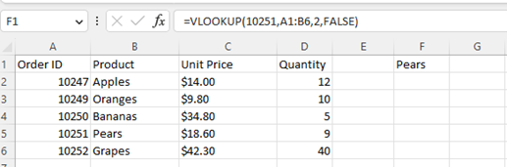

## HLOOKUP Function

The HLOOKUP function in Microsoft Excel is a formula that allows the user to search for a specific value in a table and retrieve information from that table based on a specified row. This function is similar to the VLOOKUP function, but searches for the lookup value in a horizontal row rather than a vertical column.

To use the HLOOKUP function, the user must first select the cell where they want to display the result. Next, they must enter the formula "=HLOOKUP(" into the cell, followed by the value they want to look up, the range of cells where the lookup value is located, the row number where the desired information is located, and the range of cells containing the table. For example, to look up the price for a specific product in a table, the formula might be "=HLOOKUP(10251, A1:G3, 2, FALSE)".

It is important to note that the HLOOKUP function can also be used with approximate matches by setting the final argument to "TRUE". This can be useful for looking up values that are not exact matches but fall within a specified range.

The result of the HLOOKUP function will be the information associated with the lookup value in the specified row of the table. This information can then be used in other formulas or functions as needed.

Overall, the HLOOKUP function in Excel is a useful tool for searching and retrieving information from large tables or databases. By using this function, users can easily look up values and retrieve associated information in a horizontal row, allowing for more efficient and effective data analysis.

Here is a screenshot to illustrate the process:

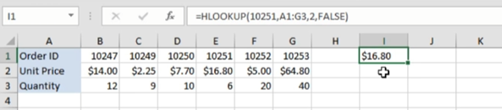

conclusion

Dear Students,

We have come to the end of this Excel functions manual for students. We hope this guide has helped you gain a solid understanding of the various functions in Excel, enabling you to efficiently manipulate data and perform calculations.

By mastering these functions, you have acquired a valuable skill set that will benefit you in your studies and future professional endeavors. Excel is a powerful tool that can streamline data analysis and improve problem-solving abilities, allowing you to make informed decisions based on accurate information.

Keep practicing and exploring the other functions available in Excel. The more you experiment and familiarize yourself with its capabilities, the more confident and skilled you will become.

Remember to stay updated with the latest features and resources available online. Excel is constantly evolving, and keeping yourself informed will enhance your efficiency and productivity.

Thank you for your commitment and dedication in learning Excel functions. We believe these skills will contribute to your academic and professional success. If you encounter any difficulties or have further questions, don't hesitate to seek assistance from your instructor or refer back to this manual.

Best of luck in your Excel endeavors and future academic pursuits.

Sincerely,

Rayane Van de Venne